OES Safety Task Analysis (STA) Plan

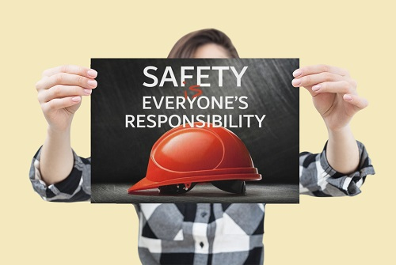

Contents

PURPOSE AND SCOPE 3

PROGRAM RESPONSIBILITIES 3

HIERARCHY OF CONTROLS 4

TRAINING 5

POINT OF CONTACT 6
APPENDIX I 7

OES Safety Task Analysis Plan

1.0 Purpose and Scope
The purpose of this written plan is to identify the safety task analysis regarding the daily involvement of Clemson University’s (CU) faculty, staff, and students. Furthermore, the task analysis in safety is the process of breaking down a task into its component subtasks, and then determining a plan for how the subtasks should be carried out safely. Having a program in place will enable our faculty, staff, and students to successfully avoid potential safety hazards they encounter on a daily basis within their scope of duties.
2.0 Program Responsibilities
Principal Investigators (PI)/Managers/Supervisors
Management has the primary responsibility for the STA program in their area. They are responsible for:
- Identifying hazards using STA.
- Identifying PPE according to the STA.
- Making sure that the STA program is followed.
- Keeping related records (test results, hazard surveys, training records, etc.).
- Requesting special exposure/health assessments from OES as necessary.
Faculty/Staff/Employees/Students
Employees are responsible for:
- Use STA in accordance with their training.
- Attend training classes.
Occupational and Environmental Safety (OES)
OES is responsible for the development, implementation, and administration of the program. These responsibilities include:
- Reviewing and updating the written program as necessary.
- Conducting exposure and health hazard evaluations of a CU workplace as necessary.
- Evaluating the overall effectiveness of the STA program.
Deciding which tasks require an STA according to:
- Accident frequency and severity.
- Newly established jobs or new machinery.
- Potential for severe injuries or illnesses.
- Infrequently performed jobs.

4.0 Hierarchy of Controls
The hierarchy of controls is a method of identifying and ranking safeguards to protect workers from hazards. They are arranged from the most to least effective and include elimination, substitution, engineering controls, administrative controls and personal protective equipment. You can see the breakdown structure in appendix I.
Elimination:
Completely take the hazard away and it no longer exists. This is the most effective method in the hierarchy of controls and should be used if available. Examples include:
- Ending the use of a hazardous material.
- Doing work at ground level rather than at heights.
- Stopping the use of noisy processes.
Substitution:
To change out a material or process to significantly reduce the hazard. Examples include:
- Switching to a less hazardous material.
- Switching to a process that uses less force, speed, temperature, or electrical current.
Engineering Controls:
Reduce exposure by preventing hazards from coming into contact with workers. This method will significantly reduce the hazard but will still allow workers to safely do their jobs. Examples include:
- Noise enclosures/sound barriers
- Local exhaust ventilation
- Guardrail system
- Machine guards
- Lift equipment
Administrative Controls:
Changes the way work is done or gives workers more information by providing them with relevant procedures, training, or warnings. Examples include:
- Procedures such as equipment inspections, planned preventive maintenance, checklists, lockout/tagout, pre- and post-task reviews.
- Training on topics such as hazard communication, permit/non-permit required confined space entry, lockout/tagout, and safe work procedures.
- Warnings such as signs, backup alarms, smoke detectors, computer messages, mirrors, horns, labels, and instructions.
Personal Protective Equipment:
Includes clothing and devices to protect the worker. This is the last step in the hierarchy of controls and should never come before any other control in this process. This is the least effective method in the hierarchy of controls and should be the last resort if no other controls are an option. Examples include:
- Safety glasses.
- Hardhats.
- Respirators.
- Hearing protection.
- Foot protection.

5.0 Training
The online training module for STA can be found on SciShield at Safety Task Analysis (STA) (Online) | SciShield.
This training provides the steps associated with the identification of an STA. Furthermore, it breaks it down as follows:
Step 1 – The task that is being conducted.
Step 2 – The identification of the hazards associated with the tasks.
Step 3 – The tools, equipment, PPE that is necessary to perform the tasks.
Step 4 – The control methods associated with the identified hazards.

6.0 Point of Contact
For any questions, comments, or matters pertaining to this written plan, please contact oeshelp@clemson.edu.

7.0 Appendices
Appendix I
Hierarchy of Controls

